How to add SObjects with the scripts

- Create the list of SObjects
- Run “add_sobjects”
- Insert the list of Objects and SObjects in the Venue.xml

Create the list of SObjects
Create a text file called sobjects.txt inside s7_walls_b with the following format:

Type Start-point End-Point Start-width End-Width

L 1466, 1493, 5.5, 5.5
L 6092, 6108, 5.5, 5.5
L 1538, 1556, 5.5, 5.5
S 1589, 1615, 4.5, 4.5
S 6302, 6789, 4.5, 4
L 1880, 1889, 4.5, 4.5

Type must be “L” or “S”. If L is used, file inicio_sobject_L.txt will be used for the SObjcect. If S is used, file inicio_sobject_S.txt will be used for the SObject.

Start point and end point are point numbers for starting and end position of the SObject. To get them, make a copy of s1_mesh\salida\anchors_carretera.geo, and delete all but the starting list of points (until the first Line is found). Then open the file with gmsh and moving the mouse on the points will tell you the point number on the status bar (bottom side of the window)
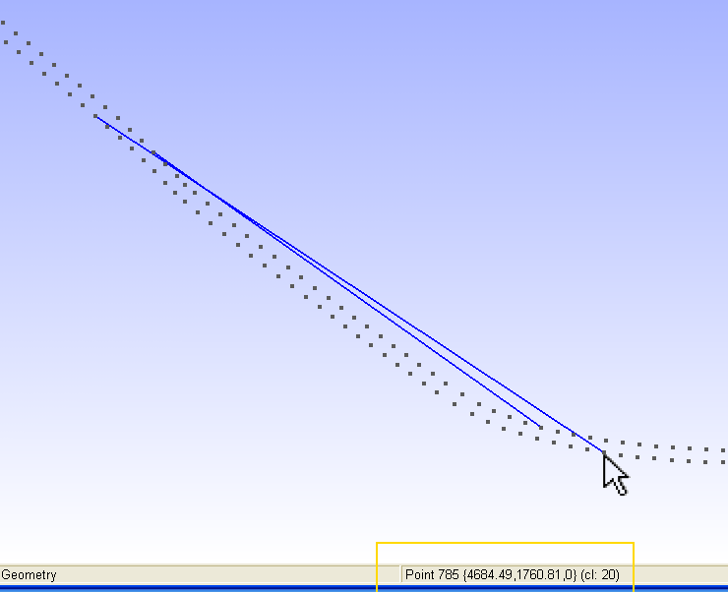
May be you could find it easier to create with gmsh Lines for L-type SObjects and 2-point Splines for S-type SObjects, selecting the start and finish points for them. Lines and Splines would then be recorded at the end of the .geo file and then you only have to process a little that file to create the sobjects.txt.

For example, the .geo file could have the following contents and we then would have to change it to have the sobjects.txt format presented above.
Line(34) = {1466, 1493}
Line(35) = {6092, 6108}
Line(36) = {1538, 1556}
Spline(37) = {1589, 1615}
Spline(38) = {6302, 6789}
Line(39) = {1880, 1889}

But this is only a trick to record easily the start and end points of the SObjects. You can write them directly to sobjects.txt from gmsh screen info.

Finally, the widths you must write inside the sobjects.txt are the “width of the road” at the start and at the end of the sobject, so if for example you use 5, 5 and you have SObjects on both sides of the road, they will be 5m apart from each other. If the road where the SObject starts is 5m width but at the end of the SObjet it is only 4.5m, then you must add 5, 4.5 at the end of that line.

2. Run add_sobjects
> cd s7_walls_b
> add_sobjects

Two files are created: salida\sobjects_L.txt and salida\sobjects_S.txt, with the list of objects. On screen you can see the total amount of SObjects: write it down, because you need it for the next step.

3. Insert the list of Objects and SObjects in the Venue.xml

BTB needs 2 changes to import the generated list of SObjects: first, the Objects that compose the SObjects must be listed. For example, the list of Objects could be changed this way to add the 4 objects used (pretil, central32, inicio and final that belong to XPack guarda):

<ObjectGroups>
<ObjectGroup Visible="True" Selected="False">
<Name>default</Name>
</ObjectGroup>
</ObjectGroups>
<Objects>
<Object>
<Name>pretil</Name>
<Path>guarda\Objects\pretil</Path>
<Instances />
</Object>
<Object>
<Name>central32</Name>
<Path>guarda\Objects\central32</Path>
<Instances />
</Object>
<Object>
<Name>inicio</Name>
<Path>guarda\Objects\inicio</Path>
<Instances />
</Object>
<Object>
<Name>final</Name>
<Path>guarda\Objects\final</Path>
<Instances />
</Object>
</Objects>

(you can find the above code in file s7_walls_b\list_objects.txt)

Then, if for example we have 122 SObjects, we would change the Venue.xml code this way:

<SObjects count=”122”>

[insert here the contents of salida\sobjets_L.txt]
[insert here the contents of salida\sobjets_S.txt]

</SObjects>

NOTE: inicio_sobject_L.txt, inicio_sobject_S.txt and list_objects.txt are just examples. You should change them to fit your needs. It is really easy because the code needed is exactly the same you will find inside the XPack of the SObject you want to use (unzip it and look for the xml files inside SObjects folder). Nevertheless if you want to use “guarda” XPack (the one I am using) for quick testing, ask for it and I will give you a link.

Example files
s7_walls_b folder with the files I used to add SObjects to my project
http://www.mediafire.com/file/mhyqigyqyya/s7_walls_b_cuevasanta.7z

The rest of the files for the project can be downloaded from
http://www.mediafire.com/file/ymjzwft4qz5/example_multitrack.7z

or from http://www.mediafire.com/file/dnyzwgy4zz5/csmt.7z in a more advanced state
(this one can’t be opened directly with BTB because a few changes need to be done to the Venue.xml to use the background images. More info can be read here: http://btbtracks-rbr.foroactivo.com/tutoriales-f31/satellite-mapping-within-btb-t454-30.htm#2460)

